REAL-TIME MULTIMODAL STRESS DETECTION USING FACIAL EXPRESSIONS AND SPEECH SIGNALS
Project Report Submitted in Partial Fulfilment of the Requirements for the Degree of

Bachelor of Technology
in

Computer Science Engineering
by
CHAGANTI SRAVYA (22B91A0538) CHILAKA SIDDHARTH (22B91A0547) D PAVAN SARADHI (22B91A0557)
BH B NAGA GAYATRI (22B91A0526)



Department of Computer Science Engineering SRKR Engineering College (A)
SRKR Marg, China Amiram, Bhimavaram - 534204 April, 2026

REAL-TIME MULTIMODAL STRESS DETECTION USING FACIAL EXPRESSIONS AND SPEECH SIGNALS
Project Report Submitted in Partial Fulfilment of the Requirements for the Degree of

Bachelor of Technology
in
Computer Science Engineering
by
CHAGANTI SRAVYA (22B91A0538) CHILAKA SIDDHARTH (22B91A0547) D PAVAN SARADHI (22B91A0557)
BH B NAGA GAYATRI (22B91A0526)

Under the Supervision of

Mr. DAVID RAJU KUPPALA

Assistant Professor

Department of Computer Science Engineering SRKR Engineering College (A)
SRKR Marg, China Amiram, Bhimavaram - 534204 April, 2026

D E C L A R A T I O N

We hereby declare that the Project Report entitled " REAL-TIME MULTIMODAL STRESS DETECTION USING FACIAL EXPRESSIONS AND SPEECH SIGNALS” which is being
submitted to the SRKR Engineering College(A), China Amiram, Bhimavaram, in partial fulfillment of the requirements for the award of the Degree of Bachelor of Technology in Computer Science Engineering is a Bonafide report of the research work carried out by us. The material contained in this Project Report has not been submitted to any University or Institution for the award of any degree.

Place: Bhimavaram CHAGANTI SRAVYA
Date: 17-04-2026 Roll No.: 22B91A0538 CHILAKA SIDDHARTH Roll No.: 22B91A0547
D PAVAN SARADHI Roll No.: 22B91A0557 BH B NAGA GAYATRI Roll No.: 22B91A0526

Department CSE
SRKR Engineering College (A), SRKR Marg, China Amiram, Bhimavaram-534204

C E R T I F I C A T E

This is to certify that the work contained in this report entitled “REAL-TIME MULTIMODAL STRESS DETECTION USING FACIAL EXPRESSIONS AND
SPEECH SIGNALS” is submitted by the group members Ms. CHAGANTI SRAVYA (22B91A0538), Ms. CHILAKA SIDDHARTH (22B91A0547), Mr. D PAVAN SARADHI
(22B91A0557), and Ms. BH B NAGA GAYATRI (22B91A0526) to the Department of Computer Science and Engineering, SRKR Engineering College, as a record of the research work carried out by them. This report is accepted as partial fulfillment of the requirements for the award of the degree of Bachelor of Technology.

Mr. DAVID RAJU KUPPALA Dr. Bh.V.S.R.K.RAJU

Supervisor Head of the Department Department of CSE Department of CSE

ACKNOWLEDGEMENT

We sincerely express our gratitude to SRKR ENGINEERING COLLEGE for providing us with the opportunity to undertake this final year project, REAL-TIME MULTIMODAL STRESS DETECTION USING FACIAL EXPRESSIONS AND SPEECH SIGNALS.
We extend our heartfelt thanks to our Principal, Dr. K. V. Murali Krishnam Raju, for fostering an academic environment that encourages research and innovation. We are also deeply grateful to Dr. Bh. V. S. R. K. Raju, Head of the Department of Computer Science & Engineering, for continuous support and motivation throughout this project.
A special thanks to our project supervisor, Mr. David Raju Kuppala, whose guidance, technical expertise, and invaluable feedback have been instrumental in shaping this work. His mentorship has provided us with both knowledge and confidence to tackle challenges effectively. We also appreciate the support of faculty members, project teammates, family, and friends, whose encouragement and insights have been invaluable.

CHAGANTI SRAVYA
(22B91A0538)
CHILAKA SIDDHARTH
(22B91A0547)
D PAVAN SARADHI
(22B91A0557)
BH B NAGA GAYATRI
(22B91A0526)

ABSTRACT
Stress significantly affects mental health, cognitive performance, and productivity, making early detection essential in modern environments. Traditional stress detection methods, such as self- reports and physiological sensors, are often intrusive, subjective, and unsuitable for continuous real-time monitoring. To address these limitations, this paper proposes a real-time multimodal stress detection system that analyzes stress levels using facial expressions and speech signals.
For facial analysis, a ConvNeXt Tiny-based deep learning model is used to extract rich visual features and classify stress levels. For speech analysis, a pretrained Wav2Vec2 model is utilized to learn meaningful acoustic representations directly from raw audio signals. The system is trained on multiple datasets, including RAF-DB for facial data and TESS, RAVDESS, and custom datasets for speech, with outputs mapped into three categories: LOW, MEDIUM, and HIGH stress. A confidence-based fusion mechanism is applied to combine predictions from both modalities by assigning higher importance to the modality with greater reliability. Experimental results demonstrate that the facial model achieves an accuracy of 97.11%, while the speech model achieves 99.15%, indicating strong performance. The proposed system operates in real time using a webcam and microphone, providing continuous and non-intrusive stress monitoring. This approach offers a robust, scalable, and practical solution for applications such as mental health monitoring, workplace analysis, and smart environments.

TABLE OF CONTENTS

S.No | CONTENTS |  |  |  | Page.No
 | Abstract |  |  |  | i
 | List Of Tables |  |  |  | iv
 | List Of Figures |  |  |  | v
1 | Introduction |  |  |  | 1
 | 1.1 |  | Problem Statement |  | 2
 | 1.2 |  | Objectives |  | 2
 | 1.3 |  | Scope |  | 3
 | 1.4 |  | Importance |  | 3
 | 1.5 |  | Reason For Choosing The Topic |  | 4
2 | Literature Review |  |  |  | 5-8
3 | Methodology/System Design |  |  |  | 9
 | 3.1 | Existing System |  |  | 9
 | 3.2 | Proposed System |  |  | 9-10
 | 3.3 | Requirements |  |  | 10
 |  | 3.3.1 |  | Software Requirements | 10-11
 |  | 3.3.2 |  | Hardware Requirements | 11
 | 3.4 | System Architecture |  |  | 12-13
 | 3.5 | Design/Proposed Model |  |  | 13

 |  | 3.5.1 | Dataset |  | 13-14
 |  |  | 3.5.1.1 | Features | 14-15
 |  |  | 3.5.1.2 | Pre-Processing | 15-16
4 | Implementation And Testing |  |  |  | 17
 | 4.1 | Implementation Approach |  |  | 17-19
 | 4.2 | Functional And Algorithmic Implementation |  |  | 19-22
 | 4.3 | Integration Details |  |  | 22
 | 4.4 | Testing |  |  | 22-23
 |  | 4.4.1 | Test Cases |  | 23-24
5 | Discussion Of Results |  |  |  | 25-34
6 | Conclusions And Future Work |  |  |  | 35-36
7 | References |  |  |  | 37-38
8 | Appendix |  |  |  | 39
 | A | Sample Code |  |  | 39-48
 | B | Project Snapshots/Screenshots |  |  | 49-51

LIST OF TABLES

S.No | LIST OF TABLES | Page.No
Table 2 | Literature Review | 5-6
Table 4.4.1.a | Test Scenarios For Multimodal Stress Detection System | 23
Table 4.4.1.b | Illustrative Test Cases With Input–Output Mapping | 24
Table 5.a | Performance Comparison Of Proposed Models With Base Paper | 26
Table 5.b | Evaluation Metrics Of Proposed Models | 30-31

LIST OF FIGURES

S.No | LIST OF FIGURES | Page.No
Figure 3.4 | System Architecture | 13
Figure 3.5.1.2.a | Face Preprocessing Steps | 15
Figure 3.5.1.2.b | Speech Preprocessing Steps | 16
Figure 4.1 | Workflow Of The Proposed Multimodal Stress Detection System | 19
Figure 4.2.a | Convnext-Tiny Based Facial Stress Detection Workflow | 20
Figure 4.2.b | Wav2vec2-Based Speech Stress Detection Workflow | 21
Figure 4.2.c | Confidence-Based Fusion Mechanism For Final Stress Prediction | 21
Figure 5.a | Accuracy Comparison Of Base Paper And Proposed Models | 27
Figure 5.b | Face Model Confussion Matrix | 27
Figure 5.c | Speech Model Confussion Matrix | 28
Figure 5.d | Gui-Based Real-Time Stress Detection Output | 32
Figure 5.e | Intermediate Output Showing Face, Speech Detection And Model Prediction | 33
Figure 8.1 | Graphical User Interface Of The Stress Detection System | 49
Figure 8.2 | Face Detection Using Webcam Input | 49
Figure 8.3 | Face Capture Interface | 50
Figure 8.4 | Audio Recording Interface | 50
Figure 8.5 | Audio Capture Interface | 51
Figure 8.6 | Final Stress Prediction Output From Gui Interface | 51

CHAPTER 1 INTRODUCTION
Stress is a prevalent psychological condition that significantly affects mental health, cognitive abilities, and overall productivity in both academic and professional environments. Prolonged exposure to stress can lead to serious health issues such as anxiety, depression, and reduced decision-making capabilities. Therefore, early and accurate detection of stress is essential for timely intervention and effective stress management.
Human stress manifests through observable behavioural patterns, particularly in facial expressions and speech signals. Facial cues such as muscle tension, frowning, and reduced expressiveness, along with speech characteristics like variations in pitch, tone, speaking rate, and vocal energy, provide reliable indicators of stress levels. These non-invasive behavioural signals make facial and speech modalities suitable for automated stress detection systems.
Traditional stress detection methods primarily rely on self-reported questionnaires or physiological sensors such as ECG and EEG. While these approaches can provide useful insights, they are often subjective, intrusive, expensive, and unsuitable for continuous real-time monitoring. Such limitations restrict their applicability in everyday environments, highlighting the need for a practical, non-intrusive, and scalable solution.
In this project, a real-time multimodal stress detection system is developed using facial expressions and speech signals. The system employs deep learning models for each modality, where facial stress is analyzed using a ConvNeXt-based architecture and speech stress is assessed using a pretrained Wav2Vec2 model. The outputs from both modalities are integrated using a confidence- based fusion strategy to improve overall accuracy and robustness. The system classifies stress into three levels: LOW, MEDIUM, and HIGH, making it suitable for real-world applications.

Problem Statement

Stress has become a common issue in modern life, affecting individuals in academic, professional, and personal environments. It negatively impacts mental health, reduces productivity, and affects cognitive functions such as concentration and decision-making. If not identified at an early stage, prolonged stress can lead to serious conditions like anxiety and depression. Therefore, accurate and timely detection of stress is essential for effective management and prevention.
Traditional stress detection methods mainly rely on self-reported questionnaires or physiological sensors such as ECG and EEG. While questionnaires are simple to use, they are subjective and may not always reflect the true mental state of an individual. On the other hand, sensor-based methods provide objective results but require specialized equipment, making them intrusive, expensive, and unsuitable for continuous real-time monitoring in everyday situations.
Moreover, existing systems that depend on a single modality, such as only facial expressions or only speech signals, often fail to provide reliable results under varying real-world conditions. Factors like poor lighting, background noise, and individual differences can reduce accuracy. Hence, there is a need for a non-intrusive, real-time, and multimodal stress detection system that combines facial and speech analysis to improve reliability and accuracy in practical environments.

Objectives

The main objective of this project is to design and develop a real-time multimodal stress detection system that can accurately classify stress levels using facial expressions and speech signals. The specific objectives are:
- To develop a non-intrusive system for real-time stress detection using webcam and microphone inputs
- To analyze facial expressions using a deep learning model based on ConvNeXt architecture

- To analyze speech signals using a pretrained Wav2Vec2 model for extracting meaningful audio features
- To implement a multimodal fusion technique that combines facial and speech predictions to improve accuracy and robustness
- To classify stress levels into LOW, MEDIUM, and HIGH categories for easy interpretation

Scope of the Study

This study focuses on the development of a real-time stress detection system using both visual and audio modalities. The system captures facial expressions through a webcam and speech signals through a microphone to analyze and estimate the stress levels of an individual. It is designed to function under normal environmental conditions without the need for specialized hardware or wearable devices, making it practical and accessible for everyday use.
The scope of this project includes key stages such as data preprocessing, feature extraction, model development, and multimodal fusion. Deep learning models are utilized to process both facial and speech inputs, and their outputs are combined to improve overall accuracy and robustness. The system is further implemented in a real-time environment with a graphical user interface, allowing users to interact with the system and view stress predictions continuously.
However, the system is limited to classifying stress into three levels: LOW, MEDIUM, and HIGH. Its performance may be affected by challenging conditions such as poor lighting, extreme facial occlusions, or high background noise during speech recording. Despite these limitations, the study provides a strong foundation for developing more advanced and scalable stress detection systems in the future.

Importance of the Work

Stress detection plays a crucial role in maintaining mental well-being and improving productivity. A non-intrusive and real-time stress monitoring system can help in early identification of stress- related issues, enabling timely intervention and preventive measures.
The proposed system offers several advantages:

- Eliminates the need for wearable sensors or manual input

- Enables continuous and real-time monitoring

- Improves reliability through multimodal analysis

- Provides a scalable solution for applications such as mental health monitoring, workplace analysis, smart learning environments, and human–computer interaction

Reason for Choosing the Topic

The increasing levels of stress in academic and professional environments, combined with the limitations of existing detection methods, motivated the selection of this topic. With advancements in deep learning and artificial intelligence, it is now possible to analyze human behaviour using non-intrusive data such as facial expressions and speech signals.
This project was chosen to explore the potential of multimodal deep learning techniques in developing a practical and efficient stress detection system. The integration of computer vision and speech processing provides an opportunity to build a robust system that can be applied in real- world scenarios for improving mental health awareness and support.

CHAPTER 2 LITERATURE REVIEW

Table 2: Literature Review

Title | Journal | Year | Author | Methodologies | Outcome | Research Gap
Real-Time | IEEE | 2022 | Madanjit | IoT-Fog-Cloud | Real-time | Deployment
Student Stress | Access |  | Singh, | layered system, | stress | challenges,
Monitoring in an |  |  | Sarveshwar | VGG16 + Bi- | classification | noisy real data,
IoT-Fog-Cloud |  |  | Bharti, Harjit | LSTM + Naïve | and alerts | coarse stress
Environment |  |  | Kaur, | Bayes for | based on | granularity
 |  |  | Vaibhav | emotion/stress | facial and
 |  |  | Arora, | detection | speech cues
 |  |  | Munish
 |  |  | Saini,
 |  |  | Manevpreet
 |  |  | Kaur,
 |  |  | Jaswinder
 |  |  | Singh
Real-Time Stress | IRJET | 2025 | S. Subha | CNN-based facial | Detects stress | Limited
Detection Using |  |  | Indu, M. | emotion | levels using | dataset, basic
Deep Learning |  |  | Harshendra, | recognition | both face and | fusion
with Facial |  |  | K. | combined with | voice in real- | technique, and
Expressions and |  |  | Bhagavath | speech emotion | time with | reduced
Vocal Signals |  |  | Kishore, J. | analysis using | improved | robustness in
 |  |  | Rubanraj | MFCC features | accuracy | noisy real-
 |  |  |  |  |  | world
 |  |  |  |  |  | environments
A Multimodal | Electronics | 2023 | V. R. | Stress detection | Improved | Requires
Late Fusion | (MDPI) |  | Xefteris. | using audio + | stress | wearable
Framework for |  |  |  | physiological | classification | sensors and
Physiological |  |  |  | signals with late | in real-time | uses limited
Sensor and Audio |  |  |  | fusion | scenarios | fusion strategy
Signal-Based
Stress Detection
Detecting | IEEE | 2019 | Jin Zhang, | Real-time stress | Achieved up | Relies only on
Negative |  |  | Xue Mei, | detection using | to 93.6% | facial
Emotional Stress |  |  | Huan Liu, | CNN-based facial | accuracy on | expressions,
Based on Facial |  |  | Shenqiang | expression | datasets such | suffers from
Expression in |  |  | Yuan, | recognition | as CK+, | class
Real Time |  |  | Tiancheng | focusing on anger, | Oulu-CASIA, | imbalance, and
 |  |  | Qian | fear, and sadness | and KMU- | lacks
 |  |  |  |  | FED | multimodal
 |  |  |  |  |  | stress analysis

Stress Recognition Using Face Images and Facial Landmarks | IEEE  Conference Publication | 2019 | Taejae Jeon, Hanbyeol Bae, Yongju Lee, Sungjun Jang, Sangyoun Lee | Stress recognition using face images and facial landmark features fed into a deep neural network with bottleneck architecture | Achieved best accuracy of 64.63% using grayscale face images combined with facial landmarks | Uses only facial information and ignores temporal dynamics and physiological or audio-based  stress cues
Facial and Speech Emotion Detection for Stress Monitoring | IJIRT | 2025 | Mrs. S. Jansi Rani, Arulmoneesh E.,  Dharaneesh R., Mahesh Veeraiah R. | CNN-based facial emotion recognition and DistilBERT-based speech emotion analysis are used to classify stress levels. | The system achieved high speech emotion accuracy with effective facial emotion  recognition. | The model lacks real-time multimodal fusion and does not use physiological stress signals.
Real-Time Stress | IJARCCE | 2024 | Hari Prasad | CNN-based facial | The system | The approach
Detection and |  |  | Chandika, | emotion | achieved high | depends only
Analysis using |  |  | Bulla | recognition is | accuracy | on facial
Facial Emotion |  |  | Soumya, | applied on live | (~98%) and | expressions and
Recognition |  |  | Baireddy | video streams | successfully | lacks
 |  |  | Naveen | using OpenCV for | analyzed real- | multimodal
 |  |  | Eswar | real-time stress | time stress | inputs;
 |  |  | Reddy, Boda | analysis. | patterns with | performance is
 |  |  | Mohana Sri |  | visual | affected by
 |  |  | Sai |  | feedback. | lighting and
 |  |  | Manideep |  |  | occlusions.
StressSpeak: A | Diagnostics | 2025 | Laraib Umer, | Real-time stress | Few-shot | The framework
Speech-Driven | (MDPI |  | Javaid Iqbal, | detection using | fine-tuned | relies only on
Framework for | Journal) |  | Yasar Ayaz, | speech input, | models | speech
Real-Time Stress |  |  | Hassan | analyzed through | achieved high | analysis, lacks
Detection |  |  | Imam, Adil | speech-to-text and | accuracy and | multimodal
 |  |  | Ahmad, | transformer-based | F1-scores, | inputs, and
 |  |  | Umer | language models | demonstrating | shows reduced
 |  |  | Asgher | (BERT, RoBERTa, | effective real- | performance in
 |  |  |  | DistilBERT, | time stress | zero-shot
 |  |  |  | LLaMA) to | detection with | settings.
 |  |  |  | classify stress | acceptable
 |  |  |  | levels. | latency.

Real-Time Student Stress Monitoring in an IoT-Fog-Cloud Environment[1](IEEE Access, 2022)This paper proposes an IoT-Fog-Cloud based framework for real-time stress monitoring using facial, speech, and textual data. It utilizes VGG16 for facial emotion detection, Bi-LSTM for speech analysis, and Naïve Bayes for text classification. The content-based emotion model achieved an accuracy of 94.23% (training) and 90.11% (validation), indicating good

performance.Results show stable training and validation behavior with low loss, confirming effective model learning. However, the system faces challenges such as noise sensitivity.
Real-Time Stress Detection Using Deep Learning with Facial Expressions and Vocal Signals[2] (IRJET, 2025)This paper proposes a multimodal stress detection system using facial expressions and speech signals. It uses CNN for feature extraction and SVM for classification, combining both modalities to improve performance. The model achieved an overall accuracy of 96.5%, with precision of 89.5%, recall of 94.4%, and F1-score of 91.8%, indicating strong classification performance. The system uses FER2013 and RAVDESS datasets for training and evaluation. Results show that multimodal fusion improves accuracy compared to single-modality approaches. However, the system relies on basic fusion techniques and lacks robustness in complex real-world environments.
A Multimodal Late Fusion Framework for Physiological Sensor and Audio Signal-Based Stress Detection[3] (Electronics, 2023)This paper proposes a multimodal stress detection system combining physiological signals (ECG, RSP, IMU) and audio features using a decision-level fusion approach. Multiple machine learning models such as SVM, kNN, RF, and XGBoost are evaluated with 10-fold cross-validation. The best physiological model achieved an MSE of 0.0567, while multimodal fusion significantly improved performance with an MSE of 0.0062. Audio-based analysis also showed strong performance with an MSE of 0.01. The results demonstrate that fusion of modalities greatly enhances stress detection accuracy. However, the system depends on wearable sensors, making it less practical for real-world deployment.
Detecting Negative Emotional Stress Based on Facial Expression in Real Time[4] (IEEE, 2019)This paper proposes a real-time stress detection framework using CNN-based facial expression recognition focusing on anger, fear, and sadness. The model combines low-level and high-level features to improve classification performance. It achieved an accuracy of 93.6% on the CK+ dataset, 81.3% on Oulu-CASIA, and 97.3% on KMU-FED, showing strong performance across datasets. The stress detection accuracy reached 91.2% (CK+), 80.4% (Oulu-CASIA), and 99.3% (KMU-FED). The system also demonstrates fast processing with around 4.3 ms per frame, enabling real-time operation. However, it relies only on facial expressions and lacks multimodal stress analysis.
Stress Recognition Using Face Images and Facial Landmarks[5] (IEEE Conference, 2019)This paper proposes a stress recognition system using facial images and facial landmark

features with a deep neural network. The model improves performance by incorporating landmark- based information along with facial images. Experimental results show that the model achieved a maximum accuracy of 64.63% using gray-scale images with facial landmarks. Without landmarks, the accuracy was significantly lower (57.92%), highlighting their importance. The dataset consists of 242,730 images from 50 subjects, ensuring balanced class distribution. However, the system relies only on facial data and lacks multimodal stress analysis.
Facial and Speech Emotion Detection for Stress Monitoring[6] (IJIRT, 2025)This paper proposes a multimodal stress detection system using facial expressions and speech signals with CNN and DistilBERT models. The DistilBERT-based speech model achieved an accuracy of approximately 95% on the test dataset. The CNN model for facial emotion recognition achieved 85% training accuracy and 87% validation accuracy, showing stable convergence. The system evaluates performance using metrics such as accuracy, precision, recall, and F1-score. Results indicate that both modalities perform well individually for stress classification. However, the system lacks effective real-time multimodal fusion and does not include physiological signals.
Real-Time Stress Detection and Analysis using Facial Emotion Recognition[7] (IJARCCE, 2024)This paper presents a real-time stress detection system using CNN-based facial emotion recognition on live video streams. The model was trained for 60 epochs, where training accuracy improved from 16.86% to 98.39%, showing strong learning capability. The system achieved an overall test accuracy of 98.00%, indicating good generalization on unseen data. Training loss decreased significantly from 2.27 to 0.066, confirming effective convergence (as shown in training graphs on results page). The system also provides visual analysis such as emotion trends and stress level graphs. However, it relies only on facial expressions and lacks multimodal integration.
StressSpeak: A Speech-Driven Framework for Real-Time Stress Detection[8] (Diagnostics, 2025)This paper proposes a speech-based stress detection system using transformer-based models such as BERT, RoBERTa, and LLaMA. The best performance was achieved by RoBERTa with an accuracy of 93.8% on the SAD dataset after few-shot fine-tuning, while LLaMA achieved an F1- score of 84.54% on the CSSRS-Suicide dataset. The system evaluates performance using accuracy, precision, recall, F1-score, and FN/FP rates across multiple datasets. Latency analysis shows processing time ranging from ~2.0 seconds to 7.6 seconds depending on model size. Results indicate strong performance in real-time stress detection with improved robustness after fine- tuning. However, the system relies only on speech input and lacks multimodal integration.

CHAPTER 3 METHODOLOGY / SYSTEM DESIGN

Existing System

The existing stress detection systems primarily rely on either single-modality approaches or traditional machine learning techniques. Most systems use either facial expression analysis or speech signals independently to detect stress, which limits their accuracy and robustness in real- world environments. Common approaches include the use of Convolutional Neural Networks (CNN) for facial feature extraction and Support Vector Machines (SVM) for classification.
Several studies have proposed hybrid models combining facial and vocal data; however, many of these systems lack effective real-time implementation and depend on basic fusion techniques. These models often struggle with environmental challenges such as lighting variations, background noise, and user diversity. Additionally, many existing systems rely on datasets like FER2013 and RAVDESS but do not generalize well across different conditions.
Furthermore, traditional approaches do not fully utilize advanced deep learning architectures and often fail to provide continuous real-time stress monitoring. The absence of robust multimodal fusion and limited scalability reduces their applicability in practical scenarios such as workplace monitoring and mental health applications.

Proposed System

The proposed system is a real-time multimodal stress detection system that integrates facial expression analysis and speech-based stress recognition using deep learning models, followed by a prediction-level fusion mechanism. The system is designed with three main components: a face- based stress detection model, a speech-based stress detection model, and a fusion module that combines the outputs of both modalities to generate a final stress prediction.
For facial stress detection, the system utilizes a ConvNeXt Tiny-based deep learning model. Input images captured from the webcam are processed through the ConvNeXt backbone, which extracts high-level spatial features representing facial expressions. These features are then passed through a fully connected classification layer to predict stress levels categorized as LOW, MEDIUM, or HIGH. The model generates class probabilities using a softmax layer, which are further used to determine the confidence of the prediction.

For speech-based stress detection, the system employs a pretrained Wav2Vec2 model for feature extraction from raw audio signals. The captured speech input is processed using the Wav2Vec2 processor to generate meaningful audio embeddings. These embeddings are then passed through a classification layer to predict stress levels. In this implementation, the feature extraction layers of the Wav2Vec2 model are kept frozen, and only the classification layers are trained, ensuring efficient and stable learning. Similar to the face model, the speech model also outputs class probabilities and confidence scores.
Both models operate independently and produce their respective predictions along with confidence values. These outputs are then combined using a confidence-based fusion strategy, where higher weight is assigned to the modality with greater confidence. This approach ensures robustness in real-world conditions, as the system can rely more on one modality when the other is affected by environmental factors such as poor lighting or background noise.
The system is deployed in a real-time environment using a graphical user interface, where facial data is captured through a webcam and speech data is recorded using a microphone. The predictions are continuously generated and displayed, including individual stress levels from face and speech, along with their confidence scores and a final fused stress level. This design enables non-intrusive, continuous, and reliable stress monitoring, fully aligned with the implemented models and system pipeline.

REQUIREMENTS

To successfully develop and deploy the proposed real-time multimodal stress detection system, specific software and hardware resources are required. The system integrates deep learning models for facial and speech analysis along with real-time data processing and a graphical interface, making it necessary to ensure proper computational support and library dependencies.

Software Requirements

The system is developed using Python version 3.8 or higher, which serves as the primary programming language for implementing the deep learning models, real-time processing, and application logic. The development and execution of the project are carried out using Visual Studio Code (VS Code) as the integrated development environment.
The deep learning models are implemented using the PyTorch framework, which is used for building and loading the facial stress detection model based on the ConvNeXt architecture. For

speech-based stress detection, the system uses the Hugging Face Transformers library to implement the pretrained Wav2Vec2 model along with its processor for handling raw audio inputs.
For real-time video processing and face detection, OpenCV (cv2) is used to capture frames from the webcam and process facial images. Audio input is handled using libraries such as Librosa for audio preprocessing and feature handling.
The system also uses NumPy for numerical operations and tensor manipulation required during model inference. Additionally, the Transformers library dependencies are required to support loading and running the Wav2Vec2 model.
All required libraries are installed and managed using pip, and the system runs on a Windows operating system. If available, CUDA support can be used to accelerate model inference, although the system is also capable of running on a CPU.

Hardware Requirements

The performance of the proposed system depends on adequate hardware resources due to the use of deep learning models and real-time processing. A system with a multi-core CPU (Intel i5/i7 or higher) is required to handle preprocessing, model inference, and GUI operations efficiently.
A minimum of 8 GB RAM is required, while 16 GB RAM is recommended for smoother performance when running both facial and speech models simultaneously. The system can operate on a CPU, but a dedicated NVIDIA GPU with CUDA support (e.g., GTX 1650 / RTX 3050 or higher) significantly improves inference speed and overall responsiveness.
For input, a webcam is required to capture facial expressions and a microphone is needed for speech input. The quality of these devices can affect system accuracy. A minimum of 10–20 GB storage is required to store datasets, models, and application files, and the use of an SSD is recommended for faster performance.
Proper device drivers and a stable power supply are also required for uninterrupted real-time operation. The performance of the system may also be affected by background applications consuming system resources. It is recommended to minimize unnecessary processes during execution to ensure smooth real-time performance. Proper system cooling is important to avoid overheating during prolonged usage. Additionally, periodic system updates and driver maintenance help in achieving consistent and reliable operation.

System Architecture

The proposed system architecture is designed to perform real-time stress detection by integrating facial and speech modalities along with a fusion mechanism. The system consists of multiple interconnected components that work sequentially to capture input data, process it, and generate the final stress prediction.
The system begins with the input layer, where real-time data is captured using a webcam and microphone. The webcam continuously captures facial images, while the microphone records speech signals. These inputs are processed independently through separate pipelines for face and speech analysis.
In the facial processing pipeline, the captured video frames are passed through a face detection module using OpenCV to extract the region of interest. The detected face is then preprocessed and fed into the ConvNeXt-based deep learning model. This model extracts high-level features from facial expressions and produces a stress prediction along with a confidence score.
In the speech processing pipeline, the recorded audio is first processed using the Wav2Vec2 processor to convert raw speech into meaningful feature representations. These features are then passed through the Wav2Vec2-based classification model, which predicts the stress level and generates a corresponding confidence score.
The outputs from both modalities are then passed to the fusion module, where a confidence-based fusion strategy is applied. The system assigns higher importance to the modality with greater confidence, ensuring reliable prediction even when one modality is affected by environmental conditions such as noise or poor lighting.
Finally, the output layer displays the results through a graphical user interface, showing the individual predictions from face and speech along with their confidence scores and the final fused stress level categorized as LOW, MEDIUM, or HIGH. The system operates continuously in real time, enabling dynamic monitoring of stress levels.
This architecture ensures a robust, non-intrusive, and real-time stress detection system, effectively combining multimodal inputs for improved accuracy and reliability.

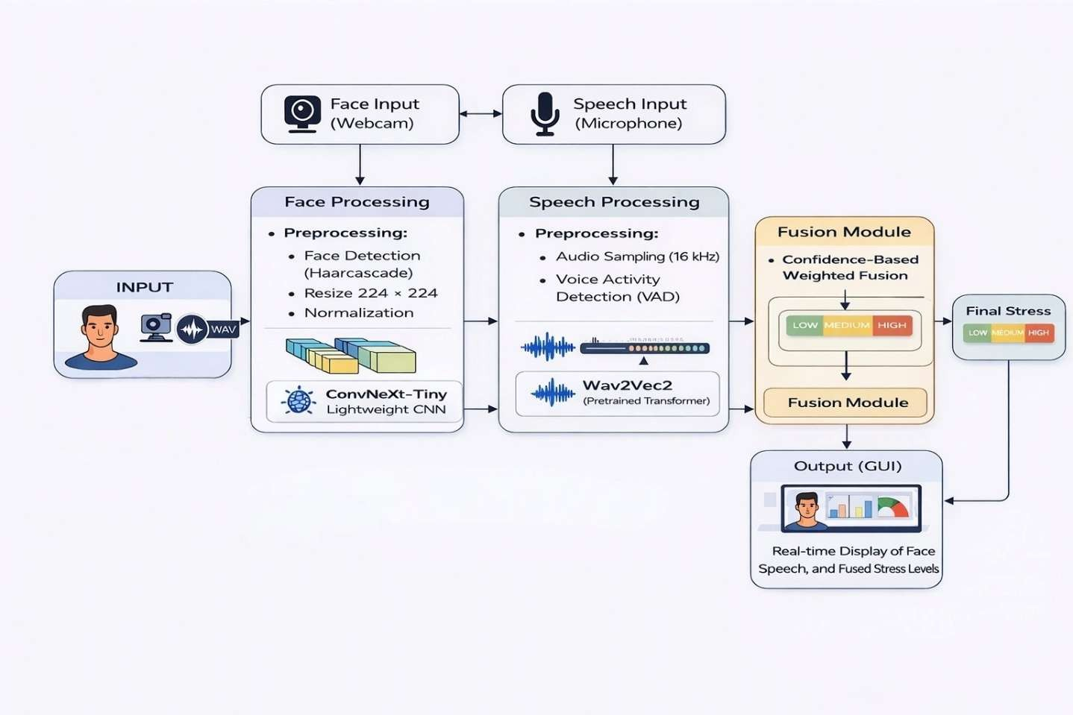

Figure 3.4: System Architecture

  - Design / Proposed Model

The proposed model is designed as a multimodal stress detection system that integrates both facial and speech-based analysis to improve prediction accuracy and robustness. The system utilizes deep learning models for each modality, where facial features are extracted using a ConvNeXt Tiny architecture and speech features are obtained using a pretrained Wav2Vec2 model. Both models operate independently to generate stress predictions along with confidence scores. These outputs are then combined using a confidence-based fusion mechanism to produce the final stress level. The overall design ensures efficient feature extraction, reliable prediction, and real-time performance, making the system suitable for practical stress monitoring applications.

Dataset

The proposed multimodal stress detection system utilizes separate datasets for facial and speech modalities to effectively learn stress-related patterns from visual and audio inputs.
For the facial modality, the system is trained using the RAF-DB (Real-world Affective Faces Database) dataset, which contains real-world facial images annotated with various emotional

expressions. This dataset is widely used for facial emotion recognition due to its diversity in pose, lighting, and expression variations. In this work, the original emotion labels are mapped into three stress categories to align with the problem statement. Specifically, happy and neutral expressions are categorized as low stress, sad and surprise as medium stress, and angry, fear, and disgust as high stress. This mapping enables the transformation of emotion recognition into stress level classification, consistent with the implemented model training pipeline.
For the speech modality, the system utilizes a combination of RAVDESS (Ryerson Audio-Visual Database of Emotional Speech and Song), TESS (Toronto Emotional Speech Set), and a custom dataset. These datasets contain audio recordings labeled with different emotional states expressed through speech. Similar to the facial dataset, the emotion labels are mapped into the same three stress categories (LOW, MEDIUM, HIGH) to maintain consistency across modalities. The use of multiple datasets increases variability in speech patterns, accents, and emotional expressions, thereby improving the robustness and generalization capability of the speech model.
Both facial and speech datasets are preprocessed and organized into training and validation sets for model development. This multimodal dataset design ensures that the system can effectively learn complementary features from both visual and auditory domains, leading to improved accuracy in real-time stress detection.

Features

The proposed system extracts meaningful features from both facial images and speech signals to accurately classify stress levels. Since the system is based on deep learning models, feature extraction is performed automatically through the respective architectures for each modality.
For the facial modality, features are extracted using the ConvNeXt Tiny model, which learns high- level spatial representations from input facial images. The model captures important visual cues such as facial muscle movements, eye patterns, and expression variations that are indicative of stress. These features are not manually defined but are learned hierarchically through convolutional layers, enabling the model to identify subtle patterns such as tension, frowning, or reduced expressiveness. The extracted features are then passed to a classification layer to predict the stress level.
For the speech modality, features are extracted using the pretrained Wav2Vec2 model, which processes raw audio signals to generate deep contextual representations. Instead of relying on traditional handcrafted features, the model learns speech characteristics such as pitch variation,

tone, speech rate, and intensity directly from the audio waveform. These features are essential for identifying stress-related changes in voice, such as irregular speech patterns or variations in vocal energy.
The use of deep learning-based feature extraction in both modalities allows the system to capture complex and subtle stress indicators without manual feature engineering. This improves the overall performance and adaptability of the system in real-world scenarios.

Pre - processing

The preprocessing stage is essential to prepare both facial images and speech signals in a format suitable for model input. Separate preprocessing steps are applied for the facial and speech modalities based on the implemented pipeline.
For the facial modality, input images from the RAF-DB dataset are first resized to a fixed resolution compatible with the ConvNeXt model. Standard image transformations such as normalization are applied to ensure consistent pixel value distribution. During training, data augmentation techniques such as random horizontal flipping are used to improve generalization.
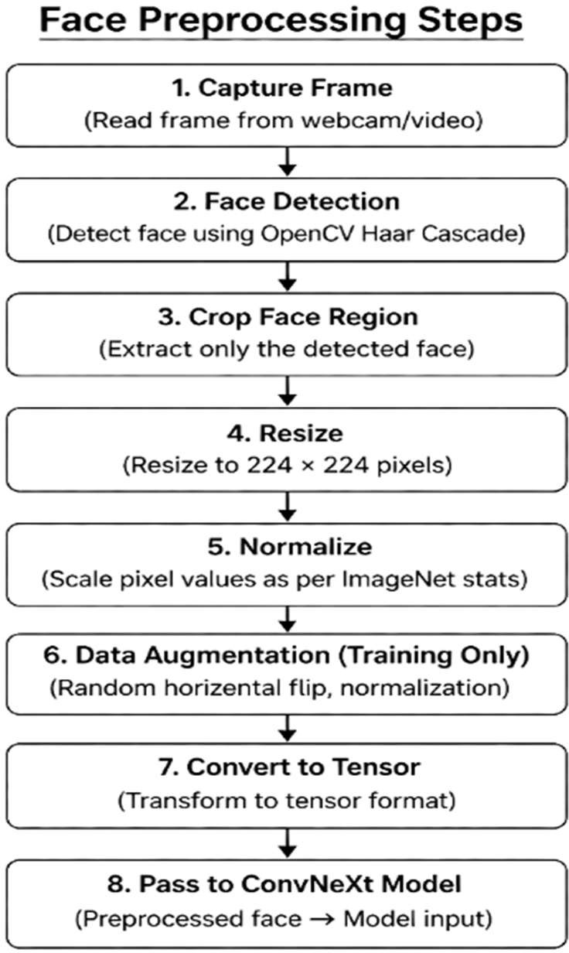

Figure 3.5.1.2.a: Face Preprocessing Steps

The images are then converted into tensors before being passed to the model. In the real-time system, frames captured from the webcam are processed using OpenCV to detect faces, and the detected face region is cropped and resized before being fed into the trained model.
For the speech modality, raw audio signals from the datasets are processed using the Wav2Vec2 processor. The audio inputs are resampled to the required sampling rate and converted into input values suitable for the model. Padding and truncation are applied to ensure uniform input length across batches. Unlike traditional methods, no handcrafted feature extraction (such as MFCC) is explicitly performed, as the Wav2Vec2 model directly learns features from raw audio. The processed audio is then converted into tensors and passed to the model for prediction.
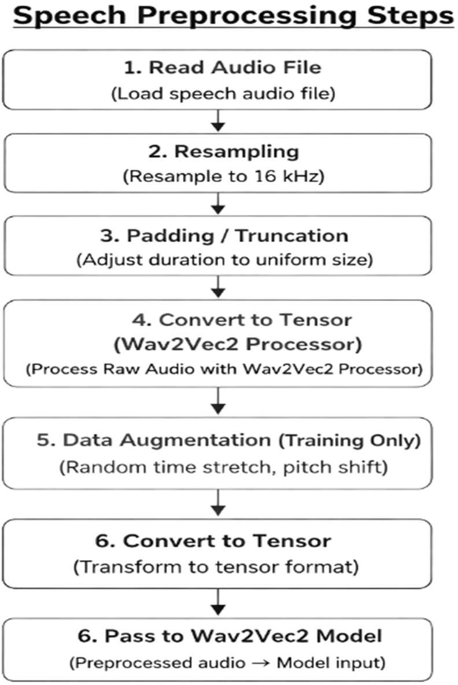

Figure 3.5.1.2.b: Speech Preprocessing Steps

Overall, the preprocessing steps ensure that both image and audio inputs are standardized, enabling efficient and accurate feature extraction by the deep learning models during both training and real- time inference.

CHAPTER 4 IMPLEMENTATION AND TESTING
The implementation focuses on developing a real-time multimodal stress detection system using facial expressions and speech signals. Deep learning models are used for both modalities, where facial stress detection is performed using a ConvNeXt-based model and speech stress detection is carried out using a pretrained Wav2Vec2 model. The outputs from both models are combined using a confidence-based fusion approach to improve prediction accuracy and robustness.
The system includes data preprocessing, model execution, and real-time inference using webcam and microphone inputs. A graphical interface is used to display the predicted stress levels along with confidence values from both modalities. Testing is performed to evaluate the performance and reliability of the system under different conditions, ensuring accurate classification of stress levels into LOW, MEDIUM, and HIGH categories.

Implementation Approach

The implementation of the proposed system is carried out in a step-by-step manner by developing separate models for facial and speech-based stress detection, followed by their integration into a real-time application with a fusion mechanism.
The process begins with dataset preparation for both modalities. For facial stress detection, images from the RAF-DB dataset are organized and mapped from emotion labels to stress categories (LOW, MEDIUM, HIGH). The images are preprocessed through resizing, normalization, and data augmentation techniques such as horizontal flipping to improve model generalization. These processed images are then used to train the facial stress detection model.
The facial model is implemented using the ConvNeXt Tiny architecture in PyTorch. A pretrained ConvNeXt backbone is used for feature extraction, and the final classification layer is modified to output three stress classes. During training, techniques such as label smoothing, mixup augmentation, gradient clipping, and learning rate scheduling are applied to improve performance and stability. The model is trained using the AdamW optimizer and evaluated on validation data to select the best-performing model.
For speech-based stress detection, audio data from RAVDESS, TESS, and custom datasets are used. The audio signals are processed using the Wav2Vec2 processor, which converts raw waveforms into suitable input features. The Wav2Vec2 pretrained model is used as a feature extractor, where

its internal layers are kept frozen, and only a classification head is trained for stress prediction. Padding and truncation are applied to handle variable-length audio inputs, and training is performed using batch processing with appropriate optimization techniques.
After training both models independently, they are integrated into a real-time system using a graphical user interface. The application captures facial input through a webcam using OpenCV and processes it to detect and crop the face region before passing it to the trained ConvNeXt model. Simultaneously, speech input is captured through a microphone and processed using the Wav2Vec2 model for prediction.
Each model produces a stress prediction along with a confidence score obtained from softmax probabilities. These outputs are then combined using a confidence-based fusion mechanism, where higher confidence predictions are given more weight to determine the final stress level. The final output is displayed in real time, showing individual predictions from face and speech along with the fused result.This implementation ensures efficient training, accurate prediction, and real-time performance by combining deep learning models with a structured processing pipeline.

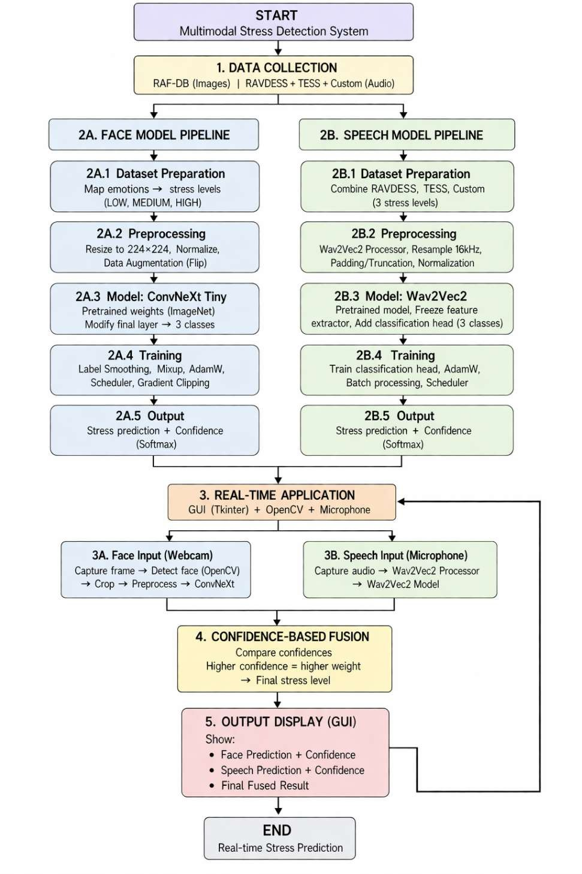

Figure 4.1: Workflow of the Proposed Multimodal Stress Detection System

  - Functional and Algorithmic Implementation

The proposed system implements a multimodal stress detection approach by combining facial and speech-based deep learning models along with a fusion mechanism. Each component of the system is designed and executed based on the implemented code pipeline.

For facial stress detection, a ConvNeXt Tiny model is used as the backbone for feature extraction. The pretrained ConvNeXt model is loaded and its final classification layer is modified to output three stress classes: LOW, MEDIUM, and HIGH. During training, the model processes input facial images and learns stress-related patterns through multiple convolutional layers. The training process includes techniques such as label smoothing to prevent overconfidence, mixup augmentation to improve generalization, and gradient clipping to stabilize training. The model is optimized using the AdamW optimizer along with a learning rate scheduler to improve convergence. The final output of the model is obtained using a softmax layer, which provides both the predicted class and its corresponding confidence score.
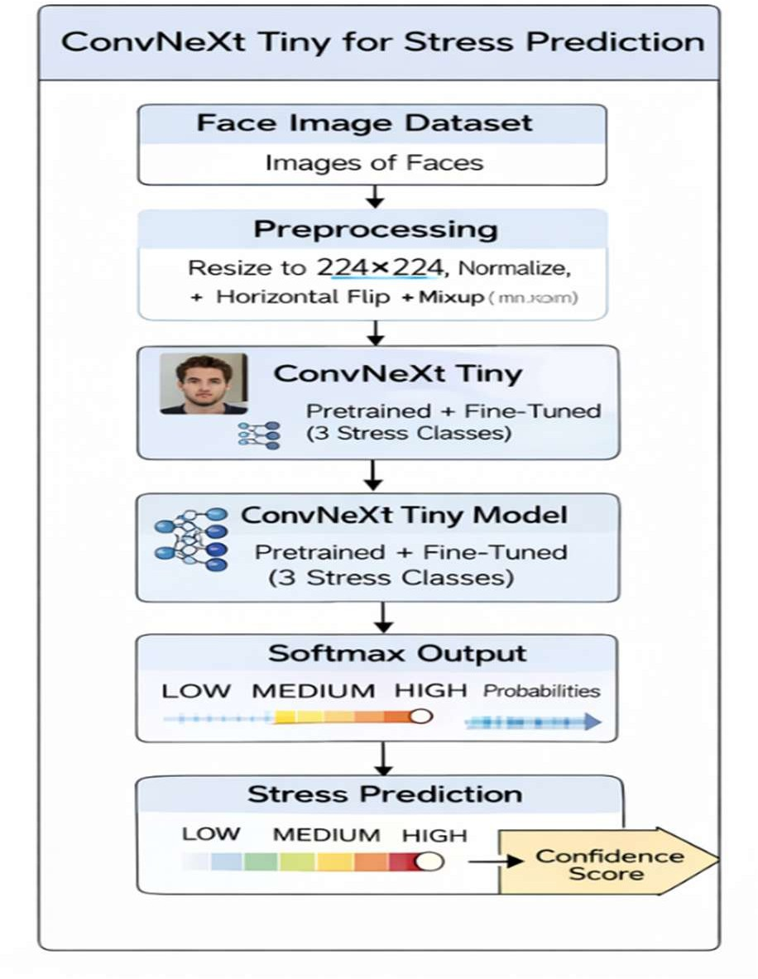

Figure 4.2.a: ConvNeXt-Tiny Based Facial Stress Detection Workflow

For speech-based stress detection, a pretrained Wav2Vec2 model is used to extract deep audio representations from raw speech signals. The Wav2Vec2 processor converts audio input into suitable feature embeddings, which are then passed to the model. In the implementation, the feature extraction layers of the Wav2Vec2 model are frozen, and only the classification head is trained to predict stress levels. This reduces computational complexity while maintaining performance. The model processes audio inputs in batches and outputs class probabilities using a softmax function, providing both prediction and confidence.

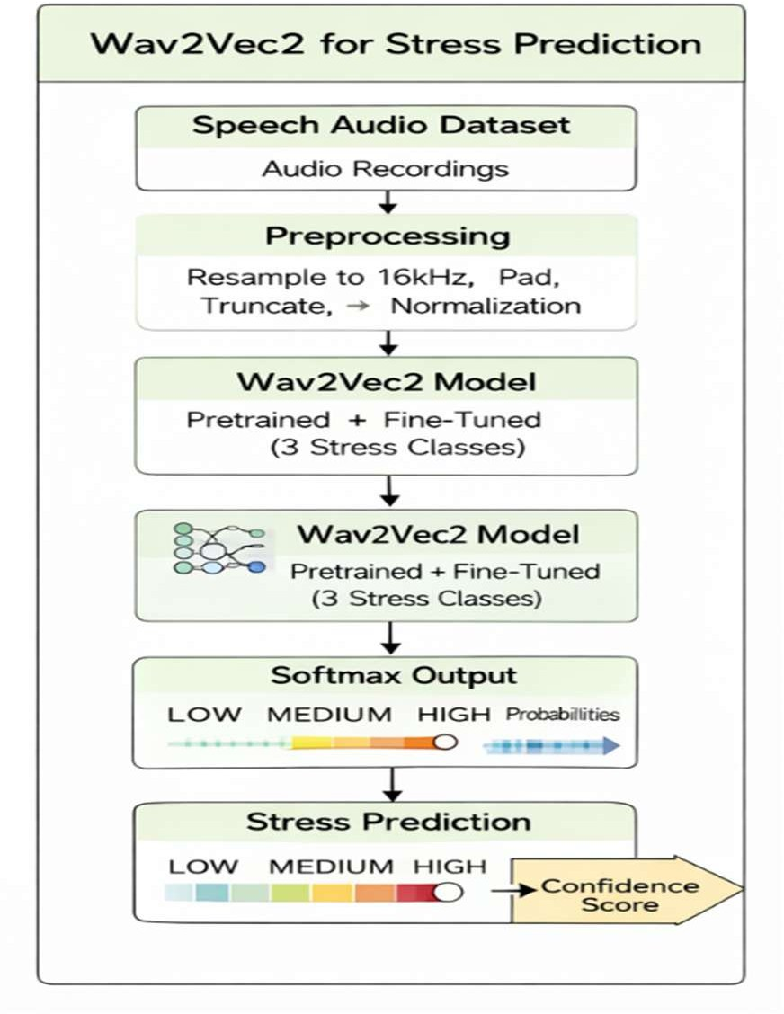

Figure 4.2.b: Wav2Vec2-Based Speech Stress Detection Workflow

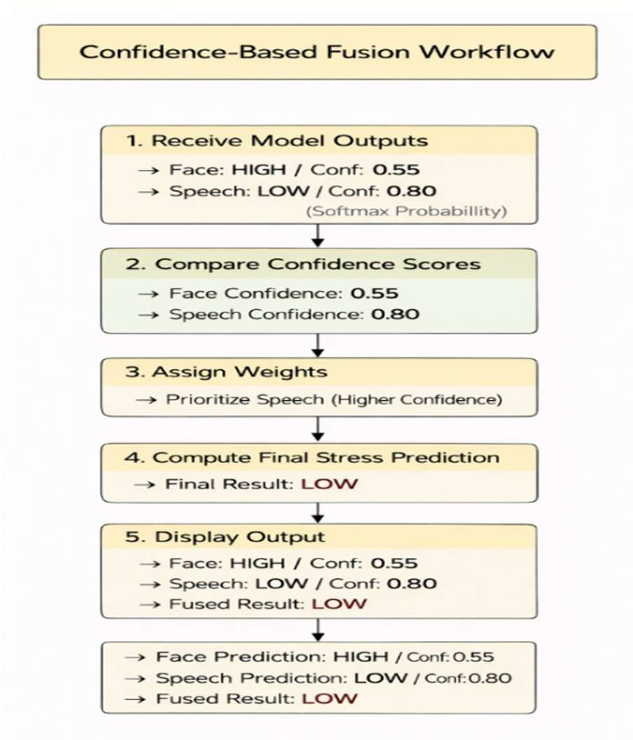
The system then applies a confidence-based fusion algorithm to combine the outputs from both modalities. The predictions from the face and speech models are compared based on their confidence scores, and higher confidence predictions are given more weight in the final decision. This ensures that the system remains robust even when one modality is affected by noise or environmental conditions

Figure 4.2.c: Confidence-Based Fusion Mechanism for Final Stress Prediction

Algorithmically, the system follows a sequential pipeline: input data is processed through respective models, predictions and confidence scores are generated, and a fusion function computes the final stress level. The final output is classified into LOW, MEDIUM, or HIGH stress and displayed through the user interface.
This implementation ensures efficient feature extraction, reliable classification, and robust multimodal integration, fully aligned with the developed system.

Integration Details

The system integrates several supporting components and libraries to enable real-time stress detection. OpenCV is used for capturing video input from the webcam and performing face detection, which provides the input for the facial stress model. For speech processing, audio input is captured using a microphone and processed using libraries compatible with the Wav2Vec2 model.
The pretrained Wav2Vec2 model from the Transformers library is integrated into the system to handle speech-based stress prediction. Additionally, the graphical user interface is integrated to display the outputs from both facial and speech models along with the final fused stress level in real time.
These supporting components work together to ensure smooth data flow, real-time processing, and effective interaction between input devices, models, and output display.

Testing

The testing of the proposed multimodal stress detection system is carried out using both unit testing and integration testing approaches to ensure correct functioning of individual components as well as the complete system pipeline.

Unit Testing:

Unit testing verifies that individual components function correctly, including facial and speech preprocessing, model forward passes (ConvNeXt and Wav2Vec2), and stress label mapping. All modules run without errors and produce accurate predictions on sample inputs.

Integration Testing:

Integration testing ensures the complete system works as a whole, combining real-time facial input (via OpenCV and ConvNeXt) and speech input (via Wav2Vec2) using a fusion mechanism. The system successfully generates stable and accurate real-time stress predictions.

Test Cases

The following section presents the evaluation of the proposed multimodal stress detection system by analyzing its performance under different scenarios. The testing focuses on validating the functionality of individual models (facial and speech) as well as the effectiveness of the confidence- based fusion mechanism in real-time conditions.

Test Scenarios Considered

The following table describes the key testing scenarios used to evaluate the system:

Table 4.4.1.a: Test Scenarios for Multimodal Stress Detection System

Test Scenario | Description
TS1:Facial Model Performance | Evaluates the accuracy of the ConvNeXt-based model in predicting stress levels from facial expressions under normal lighting conditions.
TS2: Speech Model Performance | Assesses the performance of the Wav2Vec2 model in detecting stress from speech input with clear audio.
TS3: Multimodal Fusion Performance | Evaluates the effectiveness of the confidence-based fusion mechanism in combining face and speech predictions.
TS4: Cross-Modality Conflict Handling | Evaluates system behavior when face and speech predictions differ, ensuring correct fusion decision based on confidence.

Illustrative Test Cases with Input-Output Mapping

The following table presents representative input-output relationships to demonstrate system behavior. These cases illustrate both correct predictions and possible variations under real-time conditions.

Table 4.4.1.b: Illustrative Test Cases with Input-Output Mapping

Test Case ID | Illustrative Input Description | Expected Class | Predicted Class (Example) | Status | Notes
TC001 | Neutral face + calm speech | LOW | LOW | Pass | Correct classification under normal conditions
TC002 | Angry face + aggressive speech | HIGH | HIGH | Pass | Strong stress indicators in both modalities
TC003 | Sad face + slow speech | MEDIUM | MEDIUM | Pass | Moderate stress correctly identified
TC004 | Neutral face + stressed speech | MEDIUM  / HIGH | HIGH | Pass | Fusion prioritizes speech (higher confidence)
TC005 | Stressed face + calm speech | MEDIUM  / HIGH | MEDIUM | Pass | Fusion balances conflicting inputs
TC006 | Low lighting + clear speech | LOW / MEDIUM | LOW | Pass | Face slightly affected, speech dominates
TC007 | Clear face + noisy speech | LOW / MEDIUM | LOW | Pass | Face dominates due to higher confidence
TC008 | Ambiguous facial expression | MEDIUM | LOW | Acceptable | Minor variation due to model uncertainty

The presented test cases represent typical system behaviour observed during real-time testing rather than exact dataset outputs. The system performs effectively under normal conditions and maintains stable performance even under moderate environmental variations. Minor deviations may occur in certain cases due to ambiguous facial expressions or noisy audio inputs, which can affect individual model predictions. However, the confidence-based fusion mechanism enhances overall reliability by prioritizing the modality with higher confidence, thereby ensuring consistent and accurate final stress prediction.

CHAPTER 5 DISCUSSION OF RESULTS
The results obtained from the proposed multimodal stress detection system are analyzed and interpreted to evaluate its performance, effectiveness, and reliability. The system combines facial and speech-based deep learning models along with a confidence-based fusion mechanism to improve stress prediction accuracy. The discussion focuses on evaluating individual model performance, comparing results with the base approach, analyzing classification behavior, and understanding the impact of multimodal fusion in real-time scenarios.

Overall Performance Analysis

The proposed multimodal stress detection system demonstrates strong performance across both facial and speech modalities. The facial model based on ConvNeXt Tiny achieves an accuracy of approximately 97.11%, while the speech model using Wav2Vec2 achieves a higher accuracy of around 99.15%. These results indicate that both models are capable of effectively learning stress- related patterns from their respective inputs.
The speech model shows slightly better performance compared to the facial model due to its ability to extract deep contextual features from raw audio signals. The Wav2Vec2 architecture captures variations in tone, pitch, and speech patterns, which are strong indicators of stress. In contrast, the facial model relies on visual cues such as expressions and muscle movements, which can sometimes be affected by external conditions such as lighting and camera quality.
Despite this, the facial model provides valuable complementary information, and both models contribute significantly to the overall system performance. The results clearly indicate that the combination of visual and audio-based analysis leads to a more reliable stress detection system.

Comparison with Existing/Base Paper

The performance of the proposed system is compared with the base paper approach to evaluate improvements in stress detection accuracy and reliability. The base paper utilizes a CNN-based model combined with SVM for classification, achieving an accuracy of approximately 96.50%. In contrast, the proposed system demonstrates improved performance, with the facial model achieving 97.11% accuracy and the speech model achieving 99.15% accuracy.

The improvement in performance can be attributed to the use of advanced deep learning architectures. The ConvNeXt Tiny model used for facial analysis provides better feature extraction compared to traditional CNN models by capturing more complex spatial patterns. Similarly, the Wav2Vec2 model used for speech analysis effectively learns deep representations directly from raw audio, eliminating the need for handcrafted features and improving classification accuracy.
Furthermore, the proposed system benefits from a multimodal approach, where both facial and speech information contribute to stress detection. This makes the system more robust compared to the base paper, which relies on relatively simpler models. The comparison clearly indicates that the proposed approach achieves higher accuracy, precision, and recall, demonstrating its effectiveness in real-time stress detection.

Table 5.a: Performance Comparison of Proposed Models with Base Paper

Metric | Formula | Base Paper (CNN + SVM) | Face Model (ConvNeXt- Tiny) | Speech Model (Wav2Vec2)
Accuracy | (TP + TN) / (TP  + TN + FP + FN) | 96.50% | 97.11% | 99.15%
Precision | TP / (TP + FP) | 89.50% | 97.13% | 99.16%
Recall | TP / (TP + FN) | 94.40% | 97.11% | 99.15%

The comparison table clearly shows that the proposed system outperforms the base paper across all evaluation metrics. The speech model achieves the highest performance, while the facial model also shows noticeable improvement over the baseline approach.

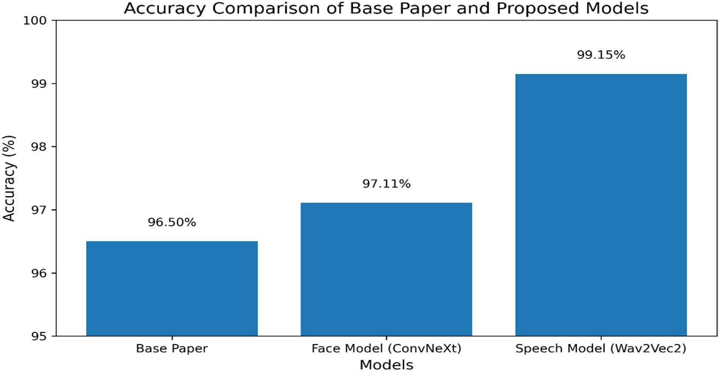

Figure 5.a: Accuracy Comparison of Base Paper and Proposed Models

The bar graph illustrates the comparison of accuracy between the base paper and the proposed models. It clearly shows that the proposed system outperforms the base approach, with the speech model achieving the highest accuracy, followed by the facial model. This improvement highlights the effectiveness of advanced deep learning architectures and the multimodal approach used in the system.

Confusion Matrix Analysis

The confusion matrix provides a detailed understanding of the classification performance of both the facial and speech models across different stress levels. It shows how accurately the system predicts each class and highlights any misclassifications between stress categories.The confusion matrix of the facial model indicates that most of the samples are correctly classified into LOW,
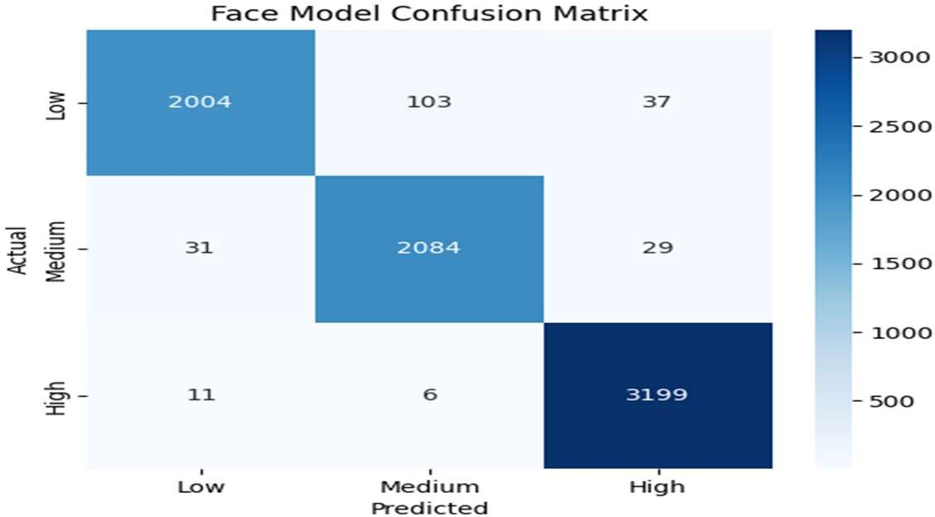

Figure 5.b: Face Model Confusion Matrix

MEDIUM, and HIGH stress categories. However, a small number of misclassifications can be observed between LOW and MEDIUM stress levels. This occurs because certain facial expressions corresponding to these stress levels may appear visually similar, making it challenging for the model to distinguish them perfectly under all conditions.
In contrast, the confusion matrix of the speech model shows near-perfect classification performance with very minimal misclassification across all classes. The model effectively captures variations in speech patterns such as tone, pitch, and intensity, which serve as strong indicators of stress levels. As a result, the speech model demonstrates higher reliability in distinguishing between different stress categories.
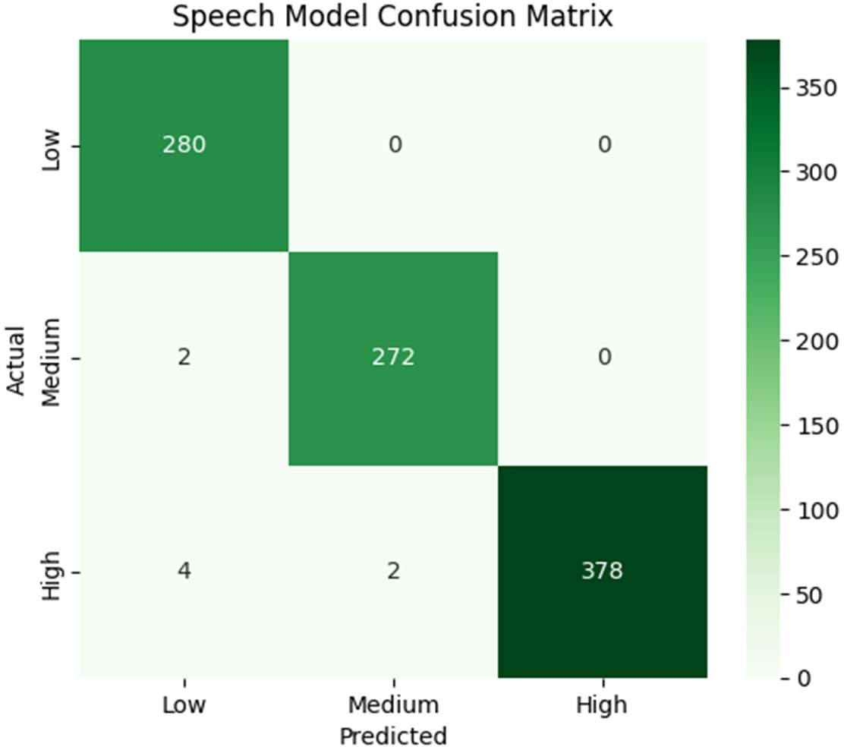

Figure 5.c: Speech Model Confusion Matrix

Overall, the confusion matrix analysis confirms that both models perform effectively, with the speech model achieving slightly better classification accuracy. The minor errors observed in the facial model are expected due to the inherent similarity between certain expressions.

Evaluation Metrics

The performance of the proposed multimodal stress detection system is evaluated using standard classification metrics including accuracy, precision, recall, F1-score, and specificity. These metrics provide a comprehensive understanding of the effectiveness of both facial and speech models in stress detection.

Accuracy

Accuracy measures the proportion of correctly classified instances out of all instances. It indicates the overall performance of the model in predicting stress levels.

where:

Accuracy =
𝑇𝑃 + 𝑇𝑁

𝑇𝑃 + 𝑇𝑁 + 𝐹𝑃 + 𝐹𝑁

- TP (True Positive): Correctly predicted stress cases

- TN (True Negative): Correctly predicted non-stress cases

- FP (False Positive): Incorrectly predicted stress cases

- FN (False Negative): Missed stress cases

The facial model achieves an accuracy of 97.11%, while the speech model achieves a higher accuracy of 99.15%, indicating that both models correctly classify many input samples. The higher accuracy of the speech model highlights its ability to capture stress-related variations more effectively.

Precision

Precision measures the proportion of correctly predicted stress cases out of all predicted stress cases. It reflects the reliability of the model in making positive predictions.

Precision =
𝑇𝑃

𝑇𝑃 + 𝐹𝑃

The precision values are 97.13% for the facial model and 99.16% for the speech model, indicating that the system produces very few false positive predictions. This ensures that predicted stress levels are highly reliable.

Recall (Sensitivity)

Recall measures the proportion of actual stress cases that are correctly identified by the model. It indicates how effectively the model detects stress without missing important instances.

Recall =
𝑇𝑃

𝑇𝑃 + 𝐹𝑁

The recall values of 97.11% for the facial model and 99.15% for the speech model show that both models can identify most of the actual stress cases, minimizing false negatives.

F1-Score

F1-score is the harmonic mean of precision and recall, providing a balanced measure of model performance.

F1 Score =
2 × (Precision × Recall) Precision + Recall

The F1-score values of 97.10% for the facial model and 99.15% for the speech model indicate a strong balance between precision and recall, demonstrating consistent and stable performance.

Specificity

Specificity measures the proportion of correctly identified non-stress cases, indicating how well the model avoids false alarms.

Specificity =
𝑇𝑁

𝑇𝑁 + 𝐹𝑃

The specificity values of 98.55% for the facial model and 99.60% for the speech model confirm that the system effectively identifies non-stress cases and minimizes incorrect classifications.

Table 5.b: Evaluation Metrics of Proposed Models

Metric | Formula | Face Model (ConvNeXt- Tiny) | Speech Model (Wav2Vec2) | Description
Accuracy | (TP + TN) / (TP + TN + FP + FN) | 97.11% | 99.15% | Represents the overall proportion of correctly classified instances (both stress and non-stress) out of all predictions made by the model.
Precision | TP / (TP + FP) | 97.13% | 99.16% | Indicates the correctness of positive predictions, i.e., how many predicted stress cases are actually correct, thereby reducing false positive rates.

Recall | TP / (TP + FN) | 97.11% | 99.15% | Measures the model’s ability to correctly identify actual stress cases, ensuring that true stress instances are not missed (sensitivity).
F1 Score | 2 × (Precision × Recall) / (Precision + Recall) | 97.10% | 99.15% | Provides a balanced evaluation by combining precision and recall, especially useful when there is a need to balance false positives and false negatives.
Specificity | TN / (TN + FP) | 98.55% | 99.60% | Measures the ability of the model to correctly identify non- stress cases, indicating how well it avoids false alarms in stress detection.

Overall Interpretation

Overall, all evaluation metrics show consistently high values for both models, confirming the reliability and effectiveness of the proposed system. The speech model slightly outperforms the facial model across all metrics due to its strong ability to capture stress-related features from audio signals. However, both models contribute significantly to accurate stress detection, making the system suitable for real-time applications.

Fusion Analysis

The proposed system incorporates a confidence-based fusion mechanism to combine predictions from both facial and speech models, improving the overall robustness and reliability of stress detection. Instead of relying on a single modality, the system dynamically integrates outputs from both models based on their confidence scores.
In this approach, each model produces a stress prediction along with a confidence value obtained from softmax probabilities. These confidence scores are used to determine the reliability of each modality. During fusion, higher importance is given to the modality with greater confidence, allowing the system to adaptively select the most reliable prediction.

This fusion strategy is particularly effective in real-time scenarios where one modality may be affected by environmental factors. For example, in low lighting conditions, the facial model performance may degrade, but the speech model can still provide reliable predictions. Similarly, in the presence of background noise, the facial model can compensate when speech input is less reliable. This complementary behavior significantly enhances the stability of the system.
Due to the use of separate datasets for facial and speech modalities, the fusion mechanism is evaluated qualitatively rather than quantitatively. However, real-time output observations confirm that the fusion process improves prediction consistency and reduces the impact of noise or ambiguity in individual models.
Overall, the confidence-based fusion mechanism plays a crucial role in improving the performance of the system, making it more robust and suitable for real-world stress detection applications.

Real-Time Output Analysis

The real-time output results demonstrate the practical effectiveness of the proposed multimodal stress detection system. The system integrates facial and speech inputs to generate stress predictions along with confidence scores and a final fused result.
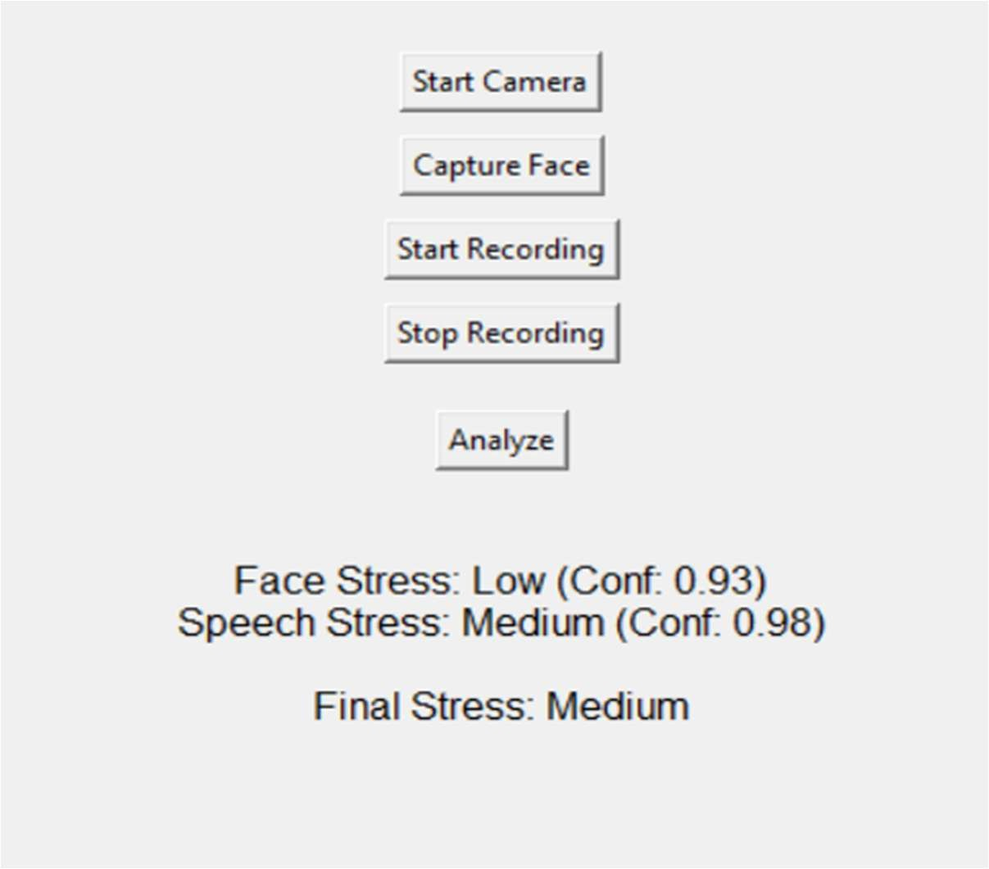
The graphical user interface (GUI) provides a user-friendly platform for interacting with the system. It allows the user to start the camera, capture facial input, record speech, and analyze stress levels in real time. The interface displays individual predictions from the facial and speech models

Figure 5.d: GUI-Based Real-Time Stress Detection Output

along with their respective confidence values, followed by the final stress level obtained through the fusion mechanism. This makes the system easy to use and enhances interpretability of the results.
The GUI output shows that the system can process both modalities effectively and producing a final stress prediction. For example, when the facial model predicts LOW stress and the speech model predicts MEDIUM stress with higher confidence, the final output is determined as MEDIUM stress based on the fusion logic. This demonstrates the dynamic decision-making capability of the system.
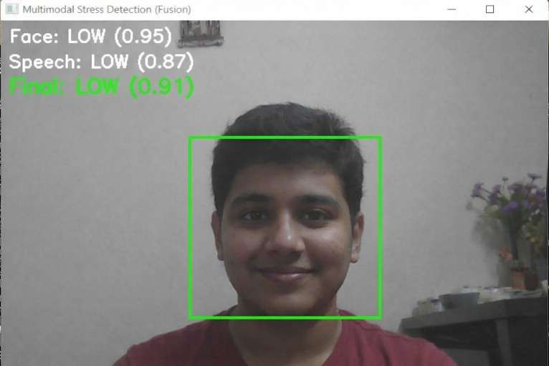
In addition to the GUI-based output, intermediate results are also analysed to understand the internal working of the system. These outputs include face detection and individual predictions generated by the facial and speech models before fusion.

Figure 5.e: Intermediate Output Showing Face,Speech Detection and Model Prediction

The intermediate outputs illustrate how the system detects the face region, processes input data, and generates predictions with confidence scores. These results confirm that the system correctly identifies stress levels at each stage and provides reliable inputs to the fusion module.
Overall, the real-time outputs demonstrate that the system performs accurately and consistently in practical scenarios. The combination of a user-friendly interface and robust prediction mechanism makes the system suitable for real-world stress monitoring applications.

Limitations

Despite the strong performance of the proposed multimodal stress detection system, certain limitations are observed. The facial model may be affected by variations in lighting conditions, camera quality, and face orientation, which can impact the accuracy of stress prediction. In low- light environments or when the face is partially occluded, the model may not capture facial features effectively.
Similarly, the speech model may be influenced by background noise, poor microphone quality, or unclear speech input. These factors can reduce the reliability of audio-based predictions, especially in real-world environments with high noise levels.
Another limitation is the use of separate datasets for facial and speech modalities. Since the datasets are not synchronized, it is not possible to perform a fully quantitative evaluation of the fusion mechanism. As a result, fusion performance is assessed qualitatively based on real-time observations.
Additionally, individual differences in facial expressions and speech patterns across users may introduce minor variations in prediction accuracy. The system may require further generalization to handle diverse real-world scenarios more effectively.

CHAPTER 6 CONCLUSIONS AND FUTURE WORK

Conclusions

The proposed real-time multimodal stress detection system has been successfully developed using both facial expressions and speech signals. By integrating these two modalities, the system is able to provide a more comprehensive and reliable analysis of human stress levels compared to single- modality approaches.
The experimental results demonstrate that the proposed system achieves better performance than the base paper across all evaluation metrics. The speech model based on Wav2Vec2 achieves the highest accuracy, highlighting its effectiveness in capturing stress-related patterns from audio signals. At the same time, the facial model based on ConvNeXt Tiny provides stable and balanced performance by analyzing visual cues such as facial expressions.
The evaluation metrics, including precision, recall, F1-score, and specificity, indicate that the system performs with high accuracy and reliability. The confusion matrix analysis further confirms that misclassifications are minimal, and the system can distinguish between different stress levels effectively.
The confidence-based fusion mechanism plays a key role in improving system robustness by combining predictions from both modalities. It ensures that the final output is reliable even when one modality is affected by environmental factors. Additionally, the implementation of a graphical user interface enhances usability and demonstrates the practical applicability of the system.
Overall, the system is efficient, non-intrusive, and suitable for real-world stress monitoring applications.

Future Work

Although the proposed system performs effectively, several improvements can be explored in future work to enhance its performance and applicability.
One important improvement is the use of properly paired facial and speech datasets, which would allow more accurate evaluation and optimization of the fusion mechanism. Enhancing system performance under real-world conditions such as background noise and low lighting is another key area for improvement.

The system can be further extended by developing a web-based or mobile-based application, making it more accessible and user-friendly. Optimization techniques can also be applied to improve processing speed and enable deployment on low-resource devices.
In addition, the system can be extended for continuous stress monitoring in environments such as educational institutions and workplaces. Incorporating advanced techniques such as temporal modeling can further improve prediction stability over time.

REFERENCES
[1]. Madanjit Singh, Sarveshwar Bharti, Vaibhav Arora, Munish Saini, Manpreet Kaur, Jaswinder Singh, “Real-Time Student Stress Monitoring in an IoT-Fog-Cloud Environment,” IEEE Access, vol. 10, pp. 1–15, 2022. This paper presents an IoT-based framework for real-time student stress monitoring using multimodal data.
[2]. S. Subha Indu, M. Harshendra, K. Bhagavath Kishore, J. Rubanraj, “Real-Time Stress Detection Using Deep Learning with Facial Expressions and Vocal Signals,” International Journal of Engineering Research & Technology (IRJET), vol. 12, 2025. This work proposes a deep learning-based multimodal approach using facial and speech data, forming the base for this project.
[3]. V. R. Xefteris et al., “A Multimodal Late Fusion Framework for Physiological Sensor and Audio Signal-Based Stress Detection,” Electronics (MDPI), vol. 12, no. 4871, pp. 1–20, 2023. This paper introduces a late fusion strategy for combining multiple modalities for improved stress detection.
[4]. Jin Zhang, Xue Mei, Huan Liu, Shenqiang Yuan, Tiancheng Qian, “Detecting Negative Emotional Stress Based on Facial Expression in Real Time,” Proceedings of IEEE International Conference, pp. 1–6, 2019. This study focuses on real-time stress detection using facial expression analysis techniques.
[5]. Taejae Jeon, Hanbyeol Bae, Yongju Lee, Sungjun Jang, Sangyoun Lee, “Stress Recognition Using Face Images and Facial Landmarks,” IEEE Conference on Affective Computing, pp. 1–8, 2019. This paper uses facial landmarks and image features to classify stress levels.
[6]. S. Jansi Rani, Arulmoneesh E., Dharaneesh R., Mahesh Veeraiah R., “Facial and Speech Emotion Detection for Stress Monitoring,” International Journal of Innovative Research in Technology (IJIRT), vol. 11, 2025. This work combines facial and speech-based emotion recognition for stress monitoring applications.
[7]. Hari Prasad Chandika, Bulla Soumya, Baidreddy Naveen, Eswar Reddy, Boda Mohana Sai,“Real-Time Stress Detection and Analysis using Facial Emotion Recognition,” International Journal of Advanced Research in Computer and Communication Engineering (IJARCCE), vol. 13, 2024. This paper focuses on real-time facial emotion recognition for stress detection.
[8]. Laraib Umer, Javaid Iqbal, Yasar Ayaz, Hassan Imam, Adil Ahmad, Umer Asgher, “StressSpeak: A Speech-Driven Framework for Real-Time Stress Detection,” Diagnostics, vol. 15,

no. 2871, pp. 1–18, 2025. This study presents a speech-based framework for detecting stress using deep learning techniques.

APPENDIX

APPENDIX A: SAMPLE CODE

Import Statements

import os import sys
import numpy as np import torch
import torch.nn as nn

from torch.utils.data import Dataset, DataLoader, random_split from torch.optim import AdamW
from torch.optim.lr_scheduler import CosineAnnealingLR from torchvision import transforms
from torchvision.models import convnext_tiny, ConvNeXt_Tiny_Weights from transformers import Wav2Vec2Model, Wav2Vec2Processor
import cv2

from PIL import Image, ImageTk import librosa
import sounddevice as sd import tkinter as tk import mediapipe as mp from tqdm import tqdm Dataset Handling:
# Face Dataset (core logic)

LOW=["neutral","happy"]

MEDIUM=["sad","surprise"] HIGH=["angry","fear","disgust"] def emotion_to_stress(emotion):
if emotion in LOW: return 0

elif emotion in MEDIUM: return 1 elif emotion in HIGH: return 2
class FaceStressDataset(Dataset):

def init (self,root_dir,split="train"): self.samples=[] split_dir=os.path.join(root_dir,split) for emotion in os.listdir(split_dir):
label=emotion_to_stress(emotion) if label is None: continue
for file in os.listdir(os.path.join(split_dir,emotion)): if file.endswith((".jpg",".png")):
self.samples.append((os.path.join(split_dir,emotion,file),label)) def getitem (self,idx):
path,label=self.samples[idx] image=Image.open(path).convert("RGB") return image,label
# Speech Dataset (core logic)

def emotion_to_stress_text(name): for e in LOW:
if e in name: return 0

for e in MEDIUM:

if e in name: return 1 for e in HIGH:
if e in name: return 2

class FullCombinedDataset(Dataset):

def init (self,tess_root,ravdess_root,custom_root): self.samples=[]
# TESS

for folder in os.listdir(tess_root): label=emotion_to_stress_text(folder) if label is None: continue
for file in os.listdir(os.path.join(tess_root,folder)): if file.endswith(".wav"):
self.samples.append((os.path.join(tess_root,folder,file),label)) # RAVDESS
for root,_,files in os.walk(ravdess_root): for file in files:
if file.endswith(".wav"): code=file.split("-")[2] if code in ravdess_map:
self.samples.append((os.path.join(root,file),ravdess_map[code])) def getitem (self,idx):
path,label=self.samples[idx]

audio,_=librosa.load(path,sr=16000)

return audio,label

Model Architecture:

#Face Model

import torch.nn as nn

from torchvision.models import convnext_tiny, ConvNeXt_Tiny_Weights class FaceStressModel(nn.Module):
def init (self, num_classes=3): super(). init ()
backbone = convnext_tiny(weights=ConvNeXt_Tiny_Weights.DEFAULT) self.features = backbone.features
self.pool = nn.AdaptiveAvgPool2d((1,1)) self.classifier = nn.Sequential(
nn.Flatten(), nn.LayerNorm(768), nn.Linear(768, 512), nn.GELU(),
nn.Dropout(0.5), nn.Linear(512, num_classes)
)

def forward(self, x): x = self.features(x) x = self.pool(x)
x = self.classifier(x)

return x

#Speech Model import torch
import torch.nn as nn

from transformers import Wav2Vec2Model class Wav2Vec2StressClassifier(nn.Module):
def init (self, num_classes=3): super(). init ()
self.wav2vec = Wav2Vec2Model.from_pretrained("facebook/wav2vec2-base") # Freeze feature extractor
for param in self.wav2vec.feature_extractor.parameters(): param.requires_grad = False
self.classifier = nn.Sequential( nn.Linear(self.wav2vec.config.hidden_size, 128), nn.ReLU(),
nn.Dropout(0.5), nn.Linear(128, num_classes)
)

def forward(self, input_values, attention_mask=None): outputs = self.wav2vec(
input_values=input_values, attention_mask=attention_mask
)
hidden_states = outputs.last_hidden_state pooled = torch.mean(hidden_states, dim=1)

logits = self.classifier(pooled) return logits

Training Procedure:

#Face Model Training

from torch.utils.data import DataLoader from torch.optim import AdamW
from torch.optim.lr_scheduler import CosineAnnealingLR import torch.nn as nn
import torch

# Dataset & Loader

train_dataset = FaceStressDataset(DATA_PATH, "train") val_dataset = FaceStressDataset(DATA_PATH, "val")
train_loader = DataLoader(train_dataset, batch_size=64, shuffle=True) val_loader = DataLoader(val_dataset, batch_size=64, shuffle=False) # Model
model = FaceStressModel().to(device) # Loss & Optimizer
criterion = nn.CrossEntropyLoss(label_smoothing=0.1)

optimizer = AdamW(model.parameters(), lr=2e-4, weight_decay=1e-4) scheduler = CosineAnnealingLR(optimizer, T_max=30)
# Training Loop (Simplified) for epoch in range(30):
model.train()

for images, labels in train_loader:

images, labels = images.to(device), labels.to(device) outputs = model(images)
loss = criterion(outputs, labels) optimizer.zero_grad() loss.backward()
torch.nn.utils.clip_grad_norm_(model.parameters(), 1.0) optimizer.step()
scheduler.step() #Speech Model Training
from torch.utils.data import DataLoader from torch.optim import AdamW import torch.nn as nn
import torch # Dataset
dataset = FullCombinedDataset(TESS_PATH, RAVDESS_PATH, CUSTOM_PATH) train_size = int(0.8 * len(dataset))
val_size = len(dataset) - train_size

train_ds, val_ds = random_split(dataset, [train_size, val_size])

train_loader = DataLoader(train_ds, batch_size=8, shuffle=True, collate_fn=collate_fn) val_loader = DataLoader(val_ds, batch_size=8, collate_fn=collate_fn)
# Model

model = Wav2Vec2StressClassifier().to(device) # Optimizer & Loss
optimizer = AdamW(model.parameters(), lr=5e-6, weight_decay=1e-4)

criterion = nn.CrossEntropyLoss() # Training Loop (Simplified)
for epoch in range(15): model.train()
for inputs, mask, labels in train_loader: inputs = inputs.to(device)
labels = labels.to(device) if mask is not None:
mask = mask.to(device)

outputs = model(inputs, mask) if mask is not None else model(inputs) loss = criterion(outputs, labels)
optimizer.zero_grad() loss.backward()
torch.nn.utils.clip_grad_norm_(model.parameters(), 1.0) optimizer.step()

Prediction, Fusion and GUI Implementation:

# MODEL LOADING

device = torch.device("cuda" if torch.cuda.is_available() else "cpu") face_model = FaceStressModel().to(device)
face_model.load_state_dict(torch.load("best_face_model.pth", map_location=device)) face_model.eval()
speech_model = Wav2Vec2StressClassifier().to(device) speech_model.load_state_dict(torch.load("wav2vec_stress_best.pth", map_location=device))
speech_model.eval()

processor = Wav2Vec2Processor.from_pretrained("facebook/wav2vec2-base") labels_map = ["Low", "Medium", "High"]
# FACE PROCESSING

def capture_face(frame):

rgb = cv2.cvtColor(frame, cv2.COLOR_BGR2RGB) results = face_detector.process(rgb)
if not results.detections: return None
bbox = results.detections[0].location_data.relative_bounding_box h, w, _ = frame.shape
x, y = int(bbox.xmin*w), int(bbox.ymin*h)

bw, bh = int(bbox.width*w), int(bbox.height*h) face = frame[y:y+bh, x:x+bw]
face = transform(Image.fromarray(cv2.cvtColor(face, cv2.COLOR_BGR2RGB))) face = face.unsqueeze(0).to(device)
with torch.no_grad(): return face_model(face)
# ---------------- SPEECH PROCESSING ----------------

def process_audio(audio):

inputs = processor(audio, sampling_rate=16000, return_tensors="pt", padding=True) input_values = inputs.input_values.to(device)
attention_mask = inputs.get("attention_mask", None) with torch.no_grad():
if attention_mask is not None:

return speech_model(input_values, attention_mask.to(device)) return speech_model(input_values)
# ---------------- FUSION MECHANISM ----------------

def fuse(face_logits, speech_logits):

face_probs = torch.softmax(face_logits, dim=1) speech_probs = torch.softmax(speech_logits, dim=1) face_conf = torch.max(face_probs).item() speech_conf = torch.max(speech_probs).item()
w_face = face_conf / (face_conf + speech_conf + 1e-6) w_speech = speech_conf / (face_conf + speech_conf + 1e-6) final_probs = w_face * face_probs + w_speech * speech_probs return torch.argmax(final_probs, dim=1).item()
# FINAL PREDICTION

def predict(face_logits, speech_logits):

if face_logits is not None and speech_logits is not None: return labels_map[fuse(face_logits, speech_logits)]
elif face_logits is not None:

return labels_map[torch.argmax(face_logits, dim=1).item()] elif speech_logits is not None:
return labels_map[torch.argmax(speech_logits, dim=1).item()] return "No Input"

APPENDIX B: PROJECT SNAPSHOTS / SCREENSHOTS
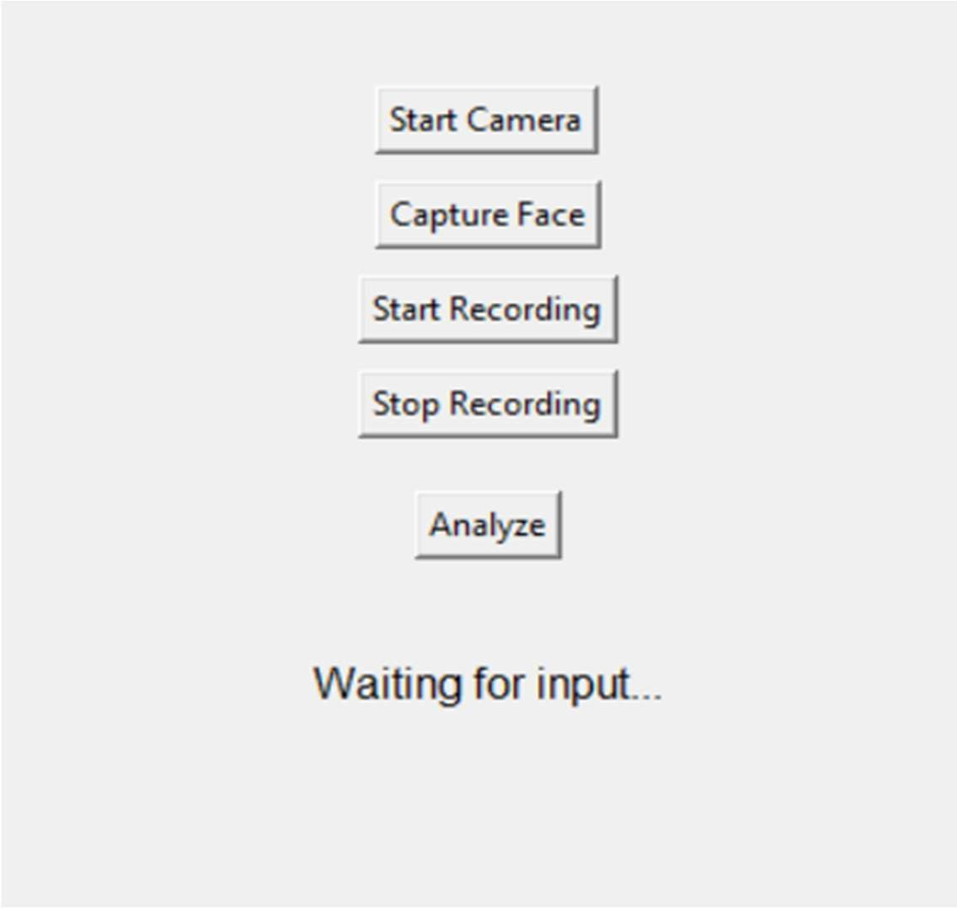

Figure 8.1: Graphical User Interface of the Stress Detection System

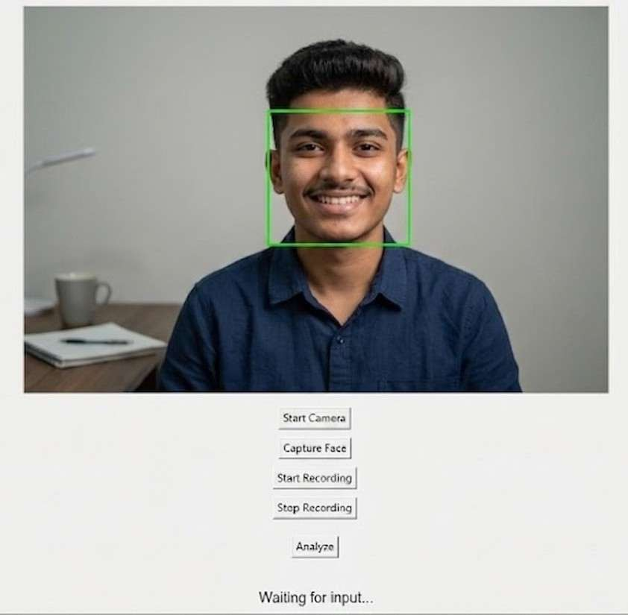

Figure 8.2: Face Detection using Webcam Input

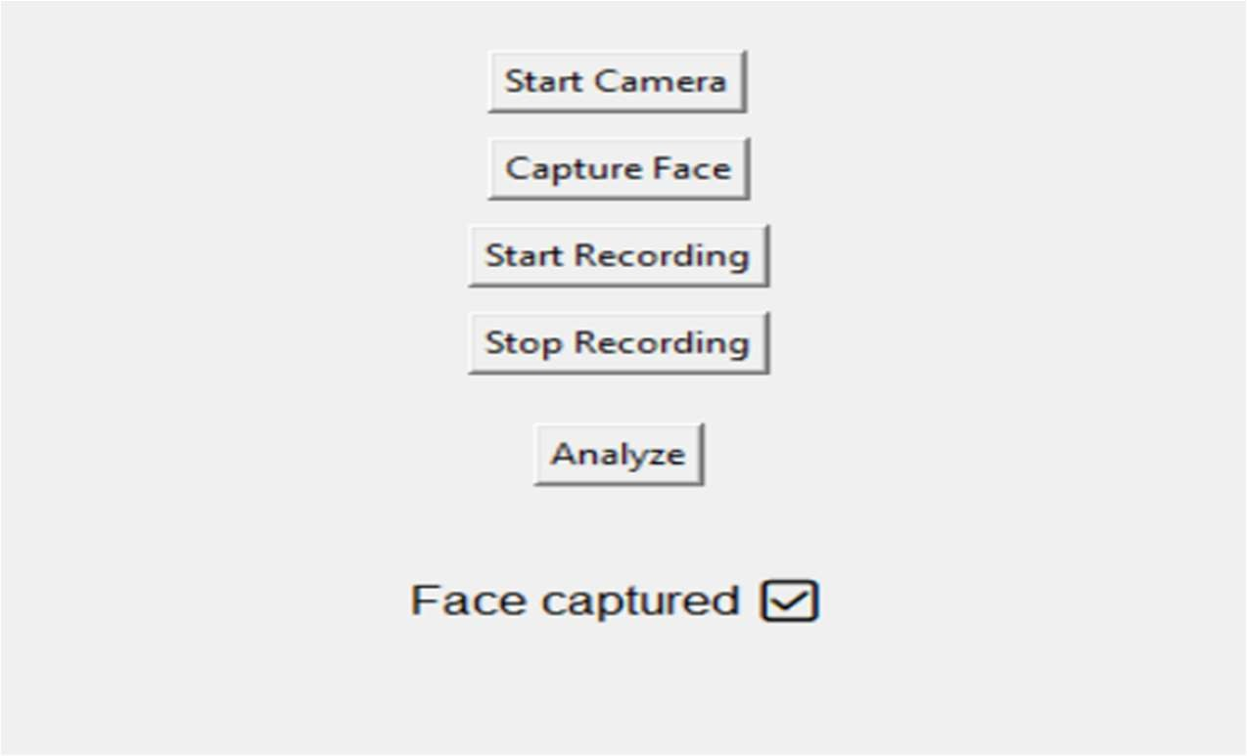

Figure 8.3: Face Capture Interface

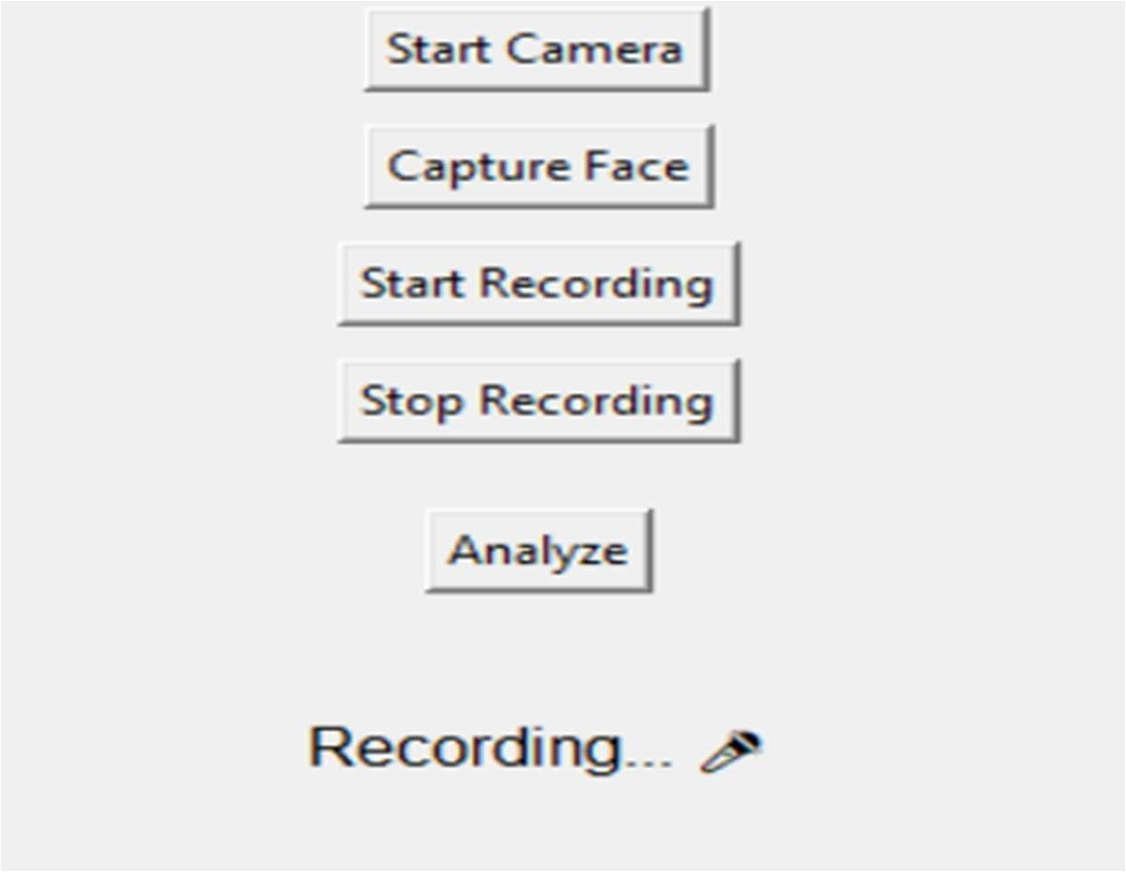

Figure 8.4: Audio Recording Interface

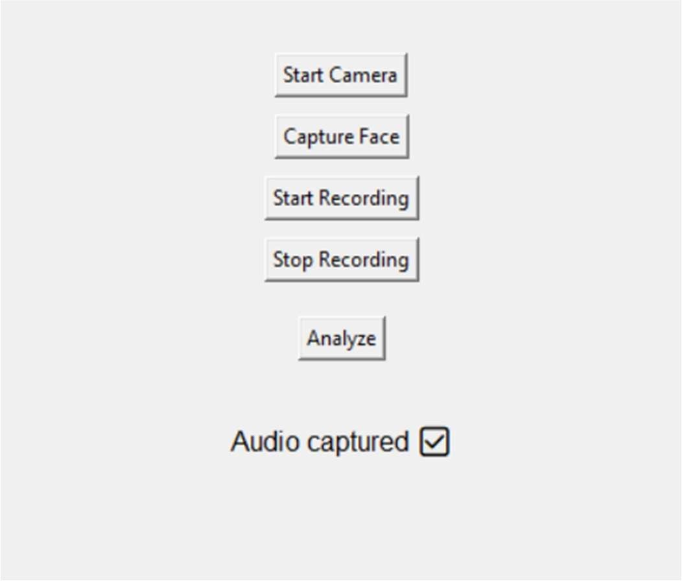

Figure 8.5: Audio Capture Interface

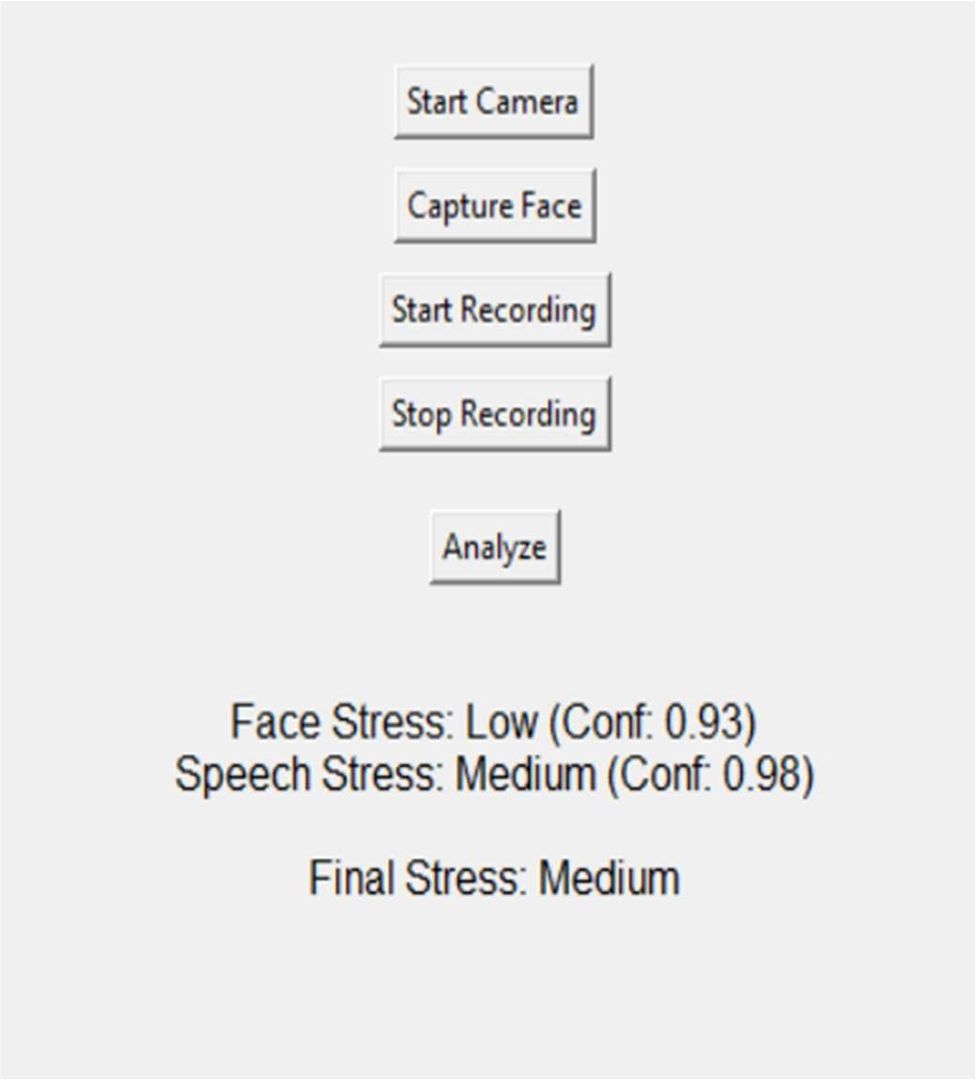

Figure 8.6: Final Stress Prediction Output from GUI Interface

